YEAR 11 PHYSICS: Heat Unit Test. Name: _________________________________
(33 marks total)
Written Section.
Where appropriate, all written answers are to include the name and explanation of the physics law or phenomena illustrated in the question.

- Students in year 9 often say that heat is how hot something is. Imaging you are teaching a year 9 class, explain to them the difference between heat and temperature. They have already studied energy in general and understand the terms potential and kinetic energy. (2 marks)

Heat is the transfer of energy from a hotter object to a cooler object until thermal equilibrium is reached. That is, until they are the same temperature.

Temperature is the measure of the average kinetic energy of all the particles that make up the object.

- While Samantha was rugged up on a cold night, she noticed that her cat’s fur seemed very fluffy. Explain why the fluffy fur would help keep the cat warm. (3 marks)

The fluffy fur helps trap air between the cat’s body and the outside environment so it restricts the transfer of heat by convection.
Air is a poor conductor so it restricts the transfer of heat by conduction from the cat’s body to the cooler outside.
As a result the cat stays warmer.

- Matthew and Veronica are looking for floor covering. Matthew feels a tiled floor and finds it too cold. Veronica feels the carpeted floor and finds it warm. When they discuss this with the salesman, he correctly informs them that the two coverings are the same temperature. If the two coverings are the same temperature, why does the tiled floor feel cold while the carpet feels warm? (3 marks)

As both floor coverings are in the same room, they have reached a thermal equilibrium with the surrounding temperature so would be the same temperature.

The carpet has a large amount of trapped air in it and is therefore a good insulator. Insulators restrict the transfer of heat so less heat is lost from your Veronica’s hand so the carpet feels warm. (Heat is measure of average kinetic energy)

The tile is a better conductor and therefore conducts the heat away from Matthew’s hand and noticeably lowers the average kinetic energy of his hand and therefore the temperature of his hand.

- 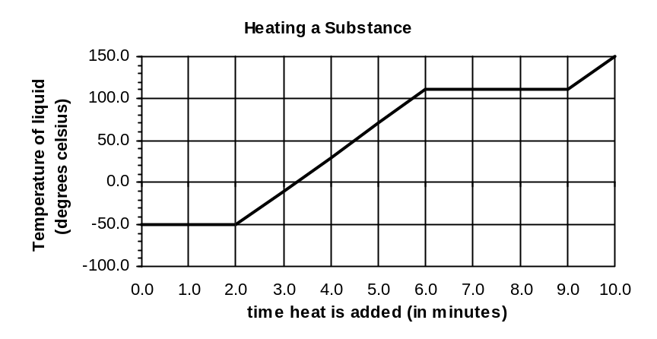A student using a bunsen burner, a thermometer, a clock and a substance in a beaker, does an experiment to obtain the following graph.

a. What phase or phases is/are present between
(i) B and C? liquid (1 mark)
(ii) C and D? liquid and gas (1 mark)
- Explain on a molecular level why the temperature doesn’t change between C and D although heat is still being added to the substance. (2 marks)

Between C and D the substance is changing phase. In phase change bonds are being broken and particles moving further apart. This involves an increase in potential energy and not kinetic energy. Temperature is the measure of the average kinetic energy so if the kinetic energy is not increasing, the temperature remains the same.

- Explain why section AB is shorter than section CD. (2 marks)
In AB the substance is changing from a solid to a liquid. While bonds are being broken, the particles are not moving much further apart.

In CD, the substance is changing from a liquid to a gas. After the bonds have been broken, extra energy is needed to move the particles much further apart in the gas and therefore much more energy is needed for particles to gain the extra potential energy to move further apart and the section is longer.

Calculation Section:

- Calculate the heat energy required to heat 0.150 kg milk (specific heat 3.90 x 10³ Jkg⁻¹K⁻¹) from 8.00⁰C to 75.0⁰C? (2 marks)

Q = mcΔT
= 0.15 x 3900 x (75 – 8)
= 39195 J

Q = 3.92 x 10⁴ J

- The graph below shows the heating curve for 0.600 kg of a solid which has been heated in a well-insulated container by a 1.00 x 10² W heater. Calculate the specific heat of the substance in its liquid phase. (3 marks)
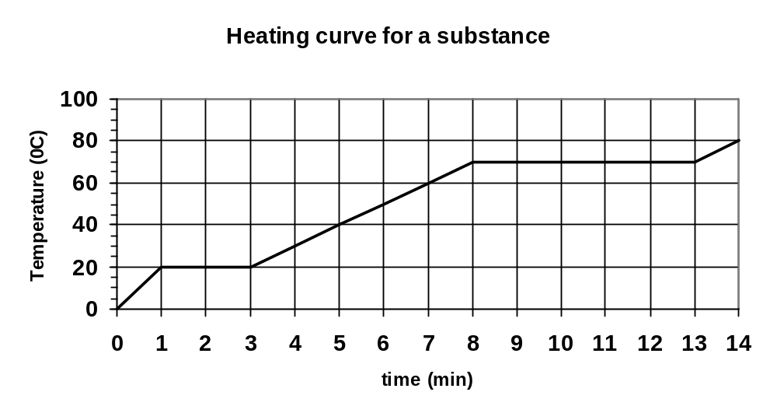
Q = 100 Js⁻¹ Q = mcΔT
t = 8 – 3 30 000 = 0.6 x c x 50
= 5 min 30 000 = 30c
= 300 s c = 1.00 x 10³ J kg⁻¹ K⁻¹
Q_{T} = energy per second x time
= 100 x 300 = 30 000 J
m = 0.600 kg
ΔT = 70 – 20
= 50

- 7.83 x 10⁵ J of heat energy is applied to ice at 0.00⁰C. What mass of the ice would melt? (2 marks)

Q = mL
m = 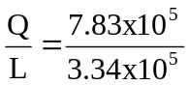
m = 2.34 kg

- 0.200 kg of steam at 108.0⁰C has heat energy removed until it becomes ice at –5.00⁰C. Calculate the amount of heat energy removed. (3 marks)

Q = cool steam + condense steam + cool water from steam + freeze water + cool ice from water
= mcΔT _{steam} + mL _{steam} + mcΔT _{water} + mL _{ice} + mcΔT _{ice}
ΔT = 8 ΔT = 100 ΔT = 5

Q = (0.2 x 2000 x 8) + (0.2 x 2.26 x 10⁶) + (0.2 x 4180 x 100) + (0.2 x 3.34 x 10⁵) + (0.2 x 2100 x 5)
= 3200 + 452000 + 83600 + 66800 + 2100
= 607700

Q = 6.08 x 10⁵ J

- You are catering for a party. If you had a suitable source which could provide you with 5.00 MJ of heat energy, as well as an unlimited supply of water at room temperature (20.0⁰C), teabags, cups (to hold 200.0 mL of tea), teaspoons, etc., how many cups of tea could you make for the party. Assume no loss of energy to the surroundings, that the water must just boil before you make the tea and that the specific heat of the tea is the same as water. (3 marks)

Q = mcΔT each cup takes 200 mL of tea
5.0 x 10⁶ = m x 4180 x 80 = 0.200 kg
m = 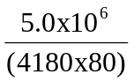 number of cups = 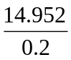
m = 14.952 kg = 74.76

therefore number of cups = 74 cups of tea

- An ice-block tray holding 0.250 kg of water at 18.0⁰C is placed in the freezing compartment of a refrigerator. If it takes 1.50 hours to form ice-blocks (at 0.00⁰C), at what rate (in Js⁻¹) was the refrigerator extracting heat from the water? (3 marks)

Q = cool water + freeze water
= (0.25 x 4180 x 18) + (0.25 x 3.34 x 10⁵)
= 18810 + 83500
Q = 102310 J

Rate = 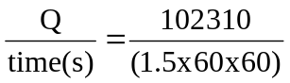
= 18.95

Rate = 19.0 Js⁻¹

- A students adds ice at –5.00⁰C to 200.0 mL of water at 80.0⁰C which is in an insulated 55.0 g copper calorimeter (specific heat 380.0 Jkg⁻¹K⁻¹). After the ice has all melted, the student takes the temperature and finds that it is 25.0⁰C. How much ice did the student add? Assume no heat loss to the surrounding air. (3 marks)

Heat lost = heat gained
Cool calorimeter + cool water = heat ice + ice melts + heat water from ice
ΔT = 80 – 25 = 55 ΔT = 5 ΔT = 25

(0.055 x 390 x 55) + (0.2 x 4180 x 55) = (m x 2100 x 5) + (m x 3.34 x 10⁵) + (m x 4180 x 25)
1179.75 + 45980 = 10500m + 3.34 x 10⁵m + 104500m
47159.75 = 449000m
m = 0.1050 kg

m = 0.105 kg ice.

